
Soft Computing IA2 report
Submitted
by
Sakshi Raut
Roll No: 16010122158
Class TY COMPS B

Department of Computer Engineering
K. J. Somaiya College of Engineering
(Constituent College of Somaiya Vidyavihar University)

Table of Contents
List of Figures ………… 3
List of Tables ………… 3
Overview ………. 3

Applications of Neuro-Fuzzy Systems: A Brief Review and Future Outline ……….
Introduction ………. 4
Hardware and Software Used ………. 4
Methodologies Used ………. 5
- Student Modeling ………. 5
- Medical Systems ………. 5
- Traffic Control ………. 5
- Economic Systems ………. 5
- Image Processing ………. 5
Inferences / Learnings from Results and Result Analysis ………. 5
- Strengths ………. 5
- Limitations ………. 6
- Results ………. 6
Suggested Improvements or Future Research Directions ………. 6
- Expertise-Oriented Methodologies ………. 6
- Applications in Social Sciences ………. 6
- Continuous Learning and Real-Time Adaptation ………. 6

A Survey on State-of-the-Art Deep Learning Applications and Challenges ………. 7
Introduction ………. 7
Hardware and Software Used ………. 8
Methodologies Used ………. 9
- Convolutional Neural Networks (CNNs) ………. 9
- Recurrent Neural Networks (RNNs) ………. 9
- Transformers and Attention Mechanisms ………. 9
- Novel Techniques and Hybrid Models ………. 9
Inferences / Learnings from Results and Result Analysis ………. 9
- Strengths of Deep Learning Models ………. 9
- Limitations of Current Models ………. 10
Suggested Improvements or Future Research Directions ………. 11
- Model Efficiency and Scalability ………. 11
- Enhancing Attention Mechanisms and Hybrid Models ………. 11
- Addressing Computational Costs ………. 11
- Improved Generalization and Robustness ………. 11

Detection of Diabetes Using Multilayer Perceptron ………. 11
Introduction ………. 11
Hardware and Software Used ………. 12
Methodologies / Approach Used ………. 12
- Data Collection and Preprocessing ………. 12
- Model Architecture ………. 12
- Training and Testing ………. 13
- Performance Evaluation ………. 13
Inferences / Learnings from Results ………. 14
- Strengths ………. 14
- Limitations ………. 14
- Error Analysis ………. 14
Suggested Improvements or Future Research Directions ........... 14
- Exploration of Other Models ………. 15
- Optimization Techniques ………. 15
- Incorporation of More Data ………. 15
- Application in Real-World Clinical Settings ………. 15

References ………. 15

List of Figures
Fig. 1. Year-wise development of NFS (Kar, Das, and Ghosh 2014) ………. 4

Fig. 2. Impact of NFS development on various categories (Kar, Das, and Ghosh 2014) ………. 5

Fig. 3. A graphical representation of a neuron (Tu et al., 2022) ………. 8

Fig. 4. The architecture of MaxViT. (Tu et al., 2022) ………. 11
Fig. 5. Trained Neural Network (Mohapatra et al. 2019) ……… 13

List of Tables
Table 1. Summary of work done in successive years. (Kar, Das, and Ghosh 2014) ………. 7
Table 2. Classification result (Mohapatra et al. 2019) ………. 13
Table 3. Result obtained by R studio (Mohapatra et al. 2019) ………. 14
Overview
This document surveys advancements in Neuro-Fuzzy Systems (NFS) and Deep Learning, featuring a case study on diabetes detection using a Multilayer Perceptron (MLP). It highlights NFS as a hybrid of fuzzy logic and neural networks, applied in fields like medical diagnosis and traffic control, with methodologies such as ANFIS and Takagi-Sugeno models enhancing decision-making. The study reviews the transformative impact of deep learning across sectors, focusing on architectures like CNNs and RNNs while addressing challenges like computational complexity. The diabetes case study showcases the MLP's accuracy in detecting diabetic patients, noting areas for improvement in identifying non-diabetic cases. The document concludes with suggestions for future research to enhance model efficiency and clinical applicability.
Applications of neuro fuzzy systems: A brief review and future outline

Introduction
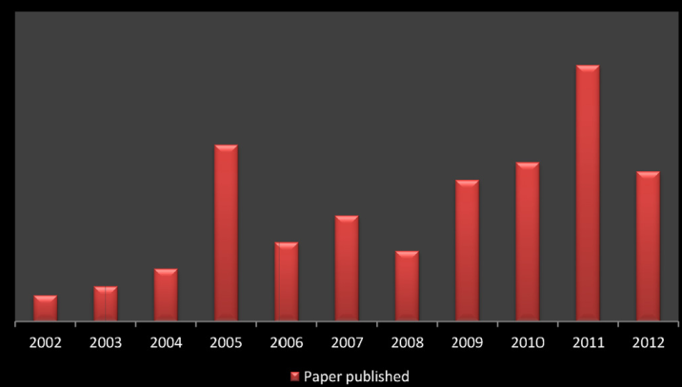
Neuro-fuzzy systems (NFS) are hybrid systems combining fuzzy logic and neural networks. These systems benefit from the interpretability of fuzzy systems (through human-like reasoning and decision-making using fuzzy rules) and the learning capability of neural networks. NFS has seen significant growth over the last decade, finding applications in various fields such as medical diagnosis, traffic control, economics, and system modeling. The primary aim of this study is to survey the development and applications of NFS between 2002 and 2012.

Fig. 1. Year wise development of NFS. (Kar, Das, and Ghosh 2014)

Hardware and Software Used
The paper does not explicitly mention hardware or software, but NFS research commonly relies on specific software tools and methods for implementation. Based on the methodologies discussed, the following can be inferred.
Software: Most of the studies discussed in the paper use MATLAB for implementing neuro-fuzzy models and simulation experiments. For example, the Adaptive Neuro-Fuzzy Inference System (ANFIS), which is a common tool in NFS research, is often modeled in MATLAB or similar platforms for simulation and analysis.
Techniques Used: The paper describes methodologies such as-
ANFIS (Adaptive Neuro-Fuzzy Inference System): Integrates fuzzy inference with neural network learning. Used widely in medical systems and forecasting models.
Takagi-Sugeno (T-S) Fuzzy Models: Employed for modeling and control in systems such as economic forecasting and industrial control.
Evolutionary Algorithms (EA) and Genetic Algorithms (GA): These are employed to optimize NFS models, improving their performance and generalization ability, particularly in control systems, classification, and decision-making.

Methodologies Used
The methodologies used in neuro-fuzzy systems across different applications are highlighted below.
Student Modeling: In student diagnosis systems, ANFIS and fuzzy neural networks have been used to assess and model students' knowledge and motivation. For example, in web-based intelligent tutoring systems (ITS), ANFIS models are implemented to track and predict student performance.
Medical Systems: NFS models, particularly fuzzy neural networks, are used to diagnose diseases such as diabetes, cancer, and heart disease. For instance, fuzzy neural filters are employed in the diagnosis of lung sound abnormalities, while ANFIS models are applied to classify medical data for brain disorders and ECG signal interpretation.
Traffic Control: In traffic management systems, adaptive neuro-fuzzy mechanisms have been implemented to control vehicle speeds, avoid congestion, and manage traffic signals. These models help in predicting road conditions and controlling network traffic dynamically.
Economic Systems: Neuro-fuzzy systems are used for stock market prediction, gas price forecasting, and supply chain management. In these applications, hybrid fuzzy-neural models are integrated with optimization algorithms like linear programming and genetic algorithms to enhance forecasting accuracy and economic decision-making.
Image Processing: Neuro-fuzzy systems are used in applications like emotion recognition, face recognition, and feature extraction. Models like Mamdani fuzzy systems and Takagi-Sugeno fuzzy models are combined with neural networks to achieve tasks such as image compression and classification.
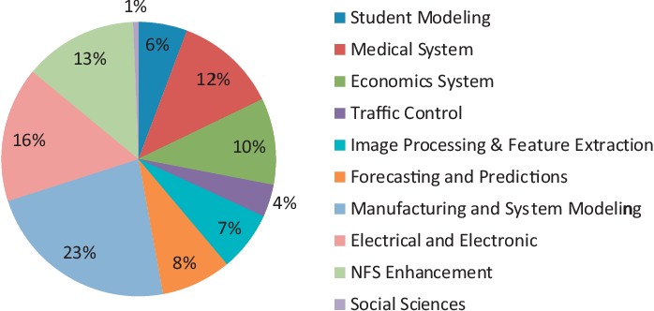
Fig. 2. Impact of NFS development on various categories. (Kar, Das, and Ghosh 2014)

Inferences / Learnings from Results and Result Analysis

Strengths
Interpretability: NFS allows for creating understandable rule-based systems (e.g., IF-THEN rules) that can be easily interpreted by humans. This makes NFS highly suitable for expert systems and decision-making tasks.
Flexibility and Learning: NFS combines the ability to learn from data through neural networks with the decision-making logic of fuzzy systems. This hybrid approach improves the model's flexibility to adapt to various applications, from control systems to medical diagnosis.
Wide Application Range: NFS has been successfully applied across a wide range of fields, including education, healthcare, traffic management, and economics. In areas like student modeling and disease diagnosis, NFS shows promising results by integrating human expert knowledge with data-driven learning.

Limitations
Complexity and Scalability: As the size of the neural network and fuzzy systems increases, the complexity of the model becomes a challenge. Large-scale NFS models may become computationally expensive, especially for real-time applications.
Learning and Adaptation: One of the significant limitations is the challenge of real-time learning and adaptation. While NFS can learn from historical data, incorporating continuous learning to adapt to dynamic changes (e.g., changing traffic conditions or stock market volatility) is still a challenge.

Results
The paper highlights successful applications of NFS in improving accuracy in medical diagnosis, traffic prediction, and stock market forecasting. In several cases, neuro-fuzzy models outperform traditional neural networks or fuzzy systems when applied in isolation.

Suggested Improvements or Future Research Directions

Expertise-Oriented Methodologies
NFS can be enhanced by integrating domain-specific expert knowledge more deeply into the systems. This will make NFS more robust in decision-making processes, particularly in complex fields like medical diagnosis and social science applications.

Applications in Social Sciences
While NFS has been widely applied in technical fields like engineering and medicine, there is potential for expanding its use in social science domains. For instance, NFS can be applied to model human behavior, social systems, or educational systems, providing expert-level decision support.

Continuous Learning and Real-Time Adaptation
Future research should focus on developing adaptive NFS models that can learn and update continuously in real-time, particularly in environments where data is constantly evolving, such as traffic management, financial markets, and healthcare.
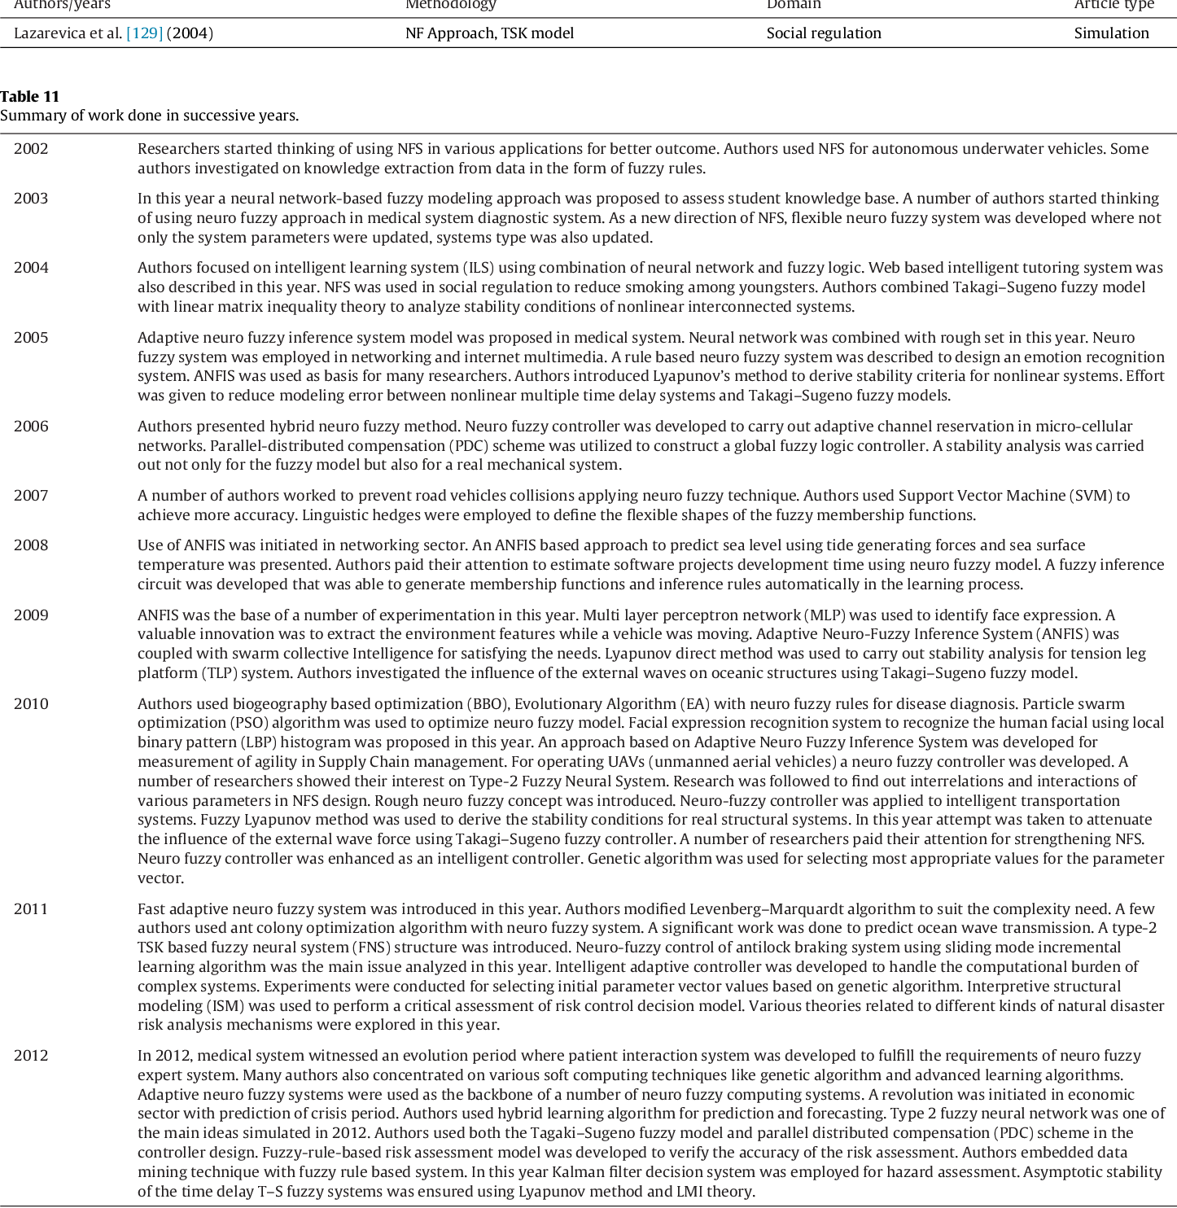
Table 1. Summary of work done in successive years. (Kar, Das, and Ghosh 2014)

A Survey on State-of-the-art Deep Learning Applications and Challenges

Introduction
The study delves into the advancements and challenges associated with deep learning, a subset of machine learning that uses multi-layered artificial neural networks to learn complex patterns from data. Deep learning has become integral to many domains, including healthcare, smart manufacturing, robotics, and cybersecurity. The study was motivated by existing surveys that mainly focus on specific types of deep learning models (e.g., CNN architectures) without fully exploring newer applications or addressing major challenges across domains. This survey aims to comprehensively review state-of-the-art deep learning models, including their applications in computer vision, natural language processing (NLP), time-series analysis, and pervasive computing. Additionally, the study provides an overview of the fundamentals of deep learning, popular architectures like CNN, and challenges related to the deployment of these models. The ultimate objective is to offer researchers and practitioners a broader perspective on leveraging deep learning to solve complex problems and identify future research directions.
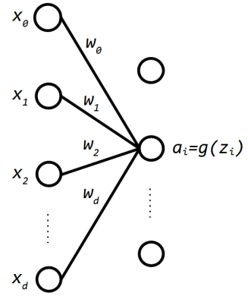Fig. 3. A graphical representation of a neuron. (Noor et al., 2022)

Hardware and Software Used for Survey of Related Work
Although the document does not explicitly describe the hardware and software used in the analysis, deep learning typically requires high-performance hardware like GPUs or TPUs for faster computation, particularly for tasks like image processing, video analysis, and large-scale natural language tasks. Software frameworks such as TensorFlow, PyTorch, or Keras are typically used for developing deep learning models, though these specific tools are not mentioned in the document.
The document provides an in-depth comparison of related work from various studies that focused on specific aspects of deep learning
Fundamentals of Deep Learning: Previous studies provided high-level overviews of deep learning concepts, focusing on types of neural networks, CNN architectures, and challenges.
Learning Approaches: Some studies explored different learning strategies, including supervised, unsupervised, and reinforcement learning, but lacked coverage of CNN architectures and deep learning applications.
CNN Architectures: Another study specifically focused on the key features of popular CNN models such as AlexNet, VGG, and ResNet, but did not cover their applications outside of medical imaging.
Deep Learning Models: A few studies reviewed applications of different deep learning models like GANs and autoencoders, but did not cover the fundamentals of deep learning.
Overall, the document emphasizes that while previous surveys have provided valuable insights, they failed to comprehensively cover emerging applications and challenges in deep learning, particularly across domains like time-series analysis, natural language processing, and pervasive computing.

Methodologies Used
Convolutional Neural Networks (CNNs): Primarily used in image-related tasks, CNNs have achieved significant breakthroughs in areas like image classification, object detection, and image segmentation. Popular models like AlexNet, VGG, ResNet, and DenseNet are discussed, with attention given to how each network improves performance by addressing challenges like vanishing gradients.
Recurrent Neural Networks (RNNs): Effective for sequential data such as time-series and natural language tasks, RNNs and their variants like Long Short-Term Memory (LSTM) networks are analyzed for their ability to retain information across time steps. This makes them suitable for tasks like human activity recognition and speech recognition.
Transformers and Attention Mechanisms: Transformers, particularly in NLP, have revolutionized the ability to capture global context in data sequences through attention mechanisms. The paper discusses the use of transformers in language models like BERT and GPT, and also their emerging use in computer vision through models like Vision Transformers (ViT).
Novel Techniques and Hybrid Models: The paper also explores hybrid models that combine CNNs with transformers to improve both local and global feature extraction, such as models used for image segmentation, human activity recognition, and time-series prediction. These architectures combine the strengths of CNNs (local feature extraction) with those of transformers (global context understanding).

Inferences / Learning from Results & Result Analysis

Strengths of Deep Learning Models
Automatic Feature Extraction: One of the key strengths of deep learning models, particularly CNNs, is their ability to automatically learn hierarchical features from data without the need for manual feature engineering. This makes them highly versatile across domains such as image recognition, language processing, and sensor data analysis.
Versatility in Application Domains: The study highlights how deep learning models have been successfully applied in diverse fields like healthcare, cybersecurity, and robotics, addressing tasks like disease diagnosis, malware detection, and object recognition.

Limitations of Current Models
Computational Complexity: One of the primary challenges is the high computational cost of training deep learning models, particularly transformers and very deep CNN architectures. Large models like BERT or GPT require significant hardware resources, and training them can be time-consuming and costly.
Vanishing Gradient Problem: In deep networks, gradients used for updating weights during backpropagation can become extremely small, making it difficult for the model to learn effectively. Although solutions like residual connections (as in ResNet) and normalization techniques have been introduced, this remains a challenge in training very deep networks.
Limited Performance on Small Objects and Global Context Understanding: CNNs, while excellent for feature extraction, often struggle with detecting small objects in images or capturing global context. Transformers, though effective in global context understanding, suffer from computational inefficiencies due to their quadratic complexity when handling high-resolution images.

Results and Model Comparisons
The document compares models like R-CNN and YOLO for object detection, highlighting how YOLO's single-shot detection method significantly improves computation time compared to the two-stage process of R-CNN. It also contrasts traditional CNN architectures with transformer-based models like ViT in tasks such as image classification, showing how transformers excel in global feature extraction but are less efficient when it comes to learning fine-grained details.
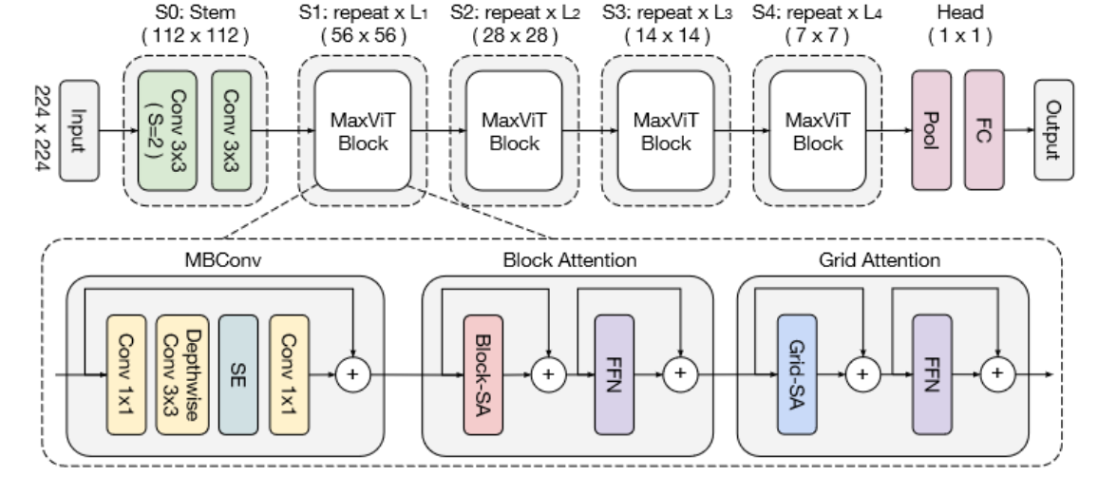
Fig4. The architecture of MaxViT. (Tu et al., 2022)

Suggested Improvements and Future Research Directions:

Model Efficiency and Scalability
The study emphasizes the need for future research to focus on improving model efficiency, particularly for tasks like image segmentation and object detection in real-time systems. One recommendation is to explore more lightweight architectures that balance model complexity with computational resources.

Enhancing Attention Mechanisms and Hybrid Models
Future research could focus on refining attention mechanisms, such as improving their ability to dynamically assign varying levels of importance to features based on task-specific requirements. Hybrid models that integrate CNNs and transformers could further be explored to better capture both local and global features in data.

Addressing Computational Costs
The paper suggests developing more efficient training strategies to mitigate the high computational cost of training large models. Techniques like pruning, quantization, and knowledge distillation are mentioned as possible areas of improvement that could reduce model size without significantly sacrificing performance.

Improved Generalization and Robustness
The paper highlights the need for better generalization in deep learning models across different data domains and tasks, recommending that future research focus on improving the robustness of models to adversarial attacks and noise, particularly in sensitive applications like healthcare and cybersecurity.

Detection of Diabetes Using Multilayer Perceptron: Proceedings of ICICA 2018

Introduction
The primary objective of this study is to develop and validate a model for detecting diabetes using a Multilayer Perceptron (MLP) neural network. Diabetes is a widespread, chronic condition that is often referred to as a "silent killer" because it exacerbates other health issues, including cardiac and kidney diseases. The motivation for the research stems from the increasing global prevalence of diabetes and the need for more effective diagnostic tools, particularly those that leverage machine learning techniques.
The study uses data from the PIMA Indian Diabetes Database, a well-known dataset, to test the MLP's ability to classify individuals with diabetes. The specific focus is on Indian women who have developed diabetes during pregnancy. The study aims to improve upon existing classification methods, such as decision trees, support vector machines (SVMs), and Naive Bayes classifiers, by demonstrating the superior accuracy of the MLP model. The ultimate goal is to offer a more reliable diagnostic tool that can assist both doctors and patients in managing diabetes.

Hardware and Software Used
The authors used two major software platforms to design, implement, and evaluate their neural network model:
R Studio: This was the primary environment for building and training the MLP neural network. R Studio was chosen because of its powerful machine learning and statistical capabilities, which allowed the researchers to preprocess the data, train the model, and analyze the results.
MATLAB: The MLP model was also verified using MATLAB, another popular tool in academic and scientific computing. MATLAB’s robust computational tools and visualization capabilities were employed to confirm the results obtained in R Studio.
Although the document does not specify the exact hardware configuration used for this study, both R Studio and MATLAB are compatible with standard computational environments, suggesting that the experiments were likely carried out on general-purpose computers with no specialized hardware, such as GPUs.

Methodologies/Approach Used
The study follows a structured machine learning pipeline using a Multilayer Perceptron (MLP) neural network. The methodology includes several key steps:

1. Data Collection and Preprocessing
The study uses the PIMA Indian Diabetes Database from the University of California, Irvine (UCI) Machine Learning Repository. This dataset contains 768 samples, each described by eight attributes (such as number of pregnancies, blood pressure, BMI, and insulin levels) and a binary class variable (indicating the presence or absence of diabetes).
The data is preprocessed to ensure it is clean and ready for model training, which involves splitting the data into training (70%, or 550 samples) and testing sets (30%, or 218 samples).

2. Model Architecture
The Multilayer Perceptron (MLP) is the core machine learning algorithm used in this study. The MLP is a type of feed-forward neural network, which consists of three types of layers: an input layer (with eight neurons, one for each feature), a hidden layer (with an unspecified number of neurons), and an output layer (with one neuron representing the binary classification outcome: diabetic or non-diabetic).
The MLP uses backpropagation as the learning method, which adjusts the weights of the network to minimize classification error during training. The network's ability to handle both linear and non-linear separations makes it suitable for this classification problem.

3. Training and Testing
The training process uses 70% of the dataset (550 samples) to optimize the model, while the remaining 30% (218 samples) are used for testing. During training, the model learns patterns in the data that help it distinguish between diabetic and non-diabetic cases.
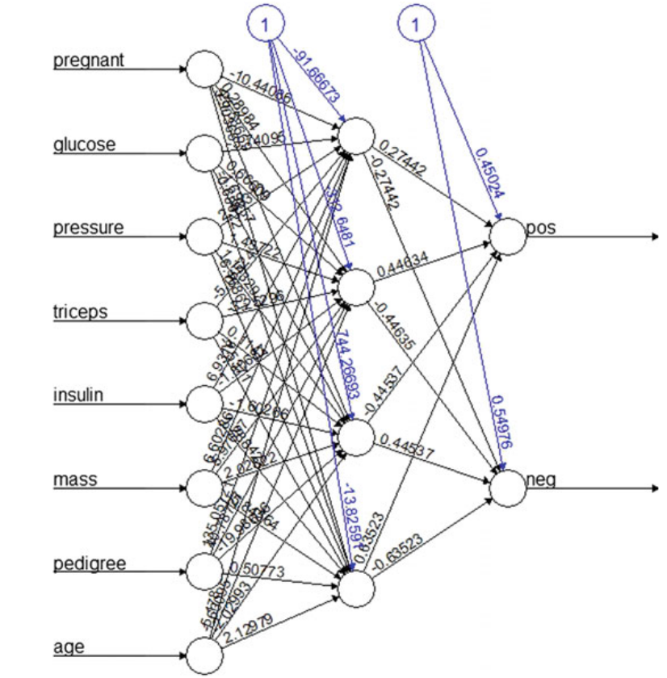
The classification performance of the model is then evaluated using the accuracy metric, which measures the proportion of correctly classified instances out of the total number of test samples.
Fig. 5. Trained Neural Network (Mohapatra et al. 2019)

4. Performance Evaluation
The final model achieves an average accuracy of 77.5%. The accuracy for predicting diabetic cases (positive class) is 85%, while the accuracy for non-diabetic cases (negative class) is 70%. This indicates that the model is better at detecting positive cases than negative ones.
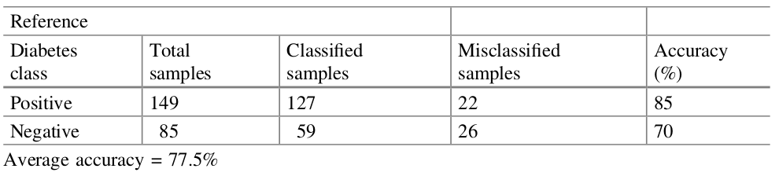
Table 2. Classification result (Mohapatra et al. 2019)

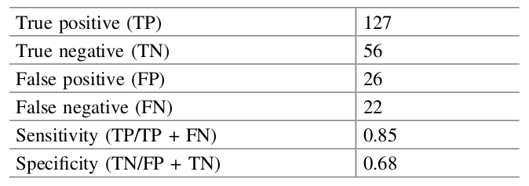
Table 3. Result obtained by R studio (Mohapatra et al. 2019)

Inferences/Learning from Results
The study's results demonstrate that the MLP model performs reasonably well, achieving an overall classification accuracy of 77.5%. The analysis of the results reveals several key insights

Strengths
The model shows a strong ability to detect diabetes in patients, with an accuracy of 85% for positive instances. This highlights the potential of MLP as a useful tool for diagnosing diabetes, particularly in women with pregnancy-induced diabetes.
The use of MLP offers significant advantages over traditional machine learning techniques, such as decision trees and support vector machines, by capturing more complex patterns in the data due to its multilayer architecture.
Limitations
One of the notable limitations is the relatively low accuracy in predicting non-diabetic cases, which stands at 70%. This imbalance suggests that while the model performs well in identifying diabetic patients, it is less reliable in ruling out diabetes for healthy individuals.
Additionally, the model's overall accuracy (77.5%) leaves room for improvement. In clinical settings, higher accuracy is often required for the model to be considered reliable enough for real-world applications.

Error Analysis
The confusion matrix provided in the results shows that some diabetic patients are misclassified as non-diabetic and vice versa. This highlights the need for further optimization of the model, particularly in improving specificity (i.e., reducing false positives).

Suggested Improvements/Future Research Directions
While the study achieves reasonable accuracy, the authors propose several avenues for future research and improvement

1. Exploration of Other Models
The authors suggest that other machine learning models should be explored to improve classification performance. Techniques like deep learning (using more advanced neural network architectures) or ensemble learning (combining multiple models) may yield better results.

2. Optimization Techniques
Applying optimization techniques, such as genetic algorithms, particle swarm optimization, or grid search, could help in fine-tuning the hyperparameters of the MLP model, thereby improving both accuracy and performance. Optimization could also involve the adjustment of the number of layers and neurons in the MLP model.

3. Incorporation of More Data
Another potential improvement is the use of larger and more diverse datasets to train the model. Expanding beyond the PIMA dataset to include data from different populations could enhance the model’s generalizability.

4. Application in Real-World Clinical Settings
The study also recommends future work to integrate these models into real-world clinical systems. Doing so would provide practical insights into how machine learning algorithms can assist doctors in diagnosing diabetes and developing personalized treatment plans.
This detailed analysis reflects the study's achievements and limitations, along with potential directions for further research.

References
- Kar, Samarjit, Sujit Das and Pijush Kanti Ghosh. “Applications of neuro fuzzy systems: A brief review and future outline.” Appl. Soft Comput. 15 (2014): 243-259.
- Noor, Mohd Halim Mohd, and Ayokunle Olalekan Ige. "A Survey on State-of-the-art Deep Learning Applications and Challenges."
- Sivasankari, S. S., J. Surendiran, N. Yuvaraj, M. Ramkumar, C. N. Ravi, and R. G. Vidhya. "Classification of diabetes using multilayer perceptron." In 2022 IEEE International Conference on Distributed Computing and Electrical Circuits and Electronics (ICDCECE), pp. 1-5. IEEE, 2022.

